ANNEX II + III: TECHNICAL SPECIFICATIONS + TECHNICAL OFFER

Contract title: Supply and delivery of uniforms and miscellaneous security equipment to the Kosovo Specialist Chambers (KSC)

p 1 /…
Publication reference: KSCR/PROC/2021-2023/0774

Columns 1-2 should be completed by the contracting authority
Columns 3-4 should be completed by the tenderer
Column 5 is reserved for the evaluation committee
Annex III - the contractor's technical offer
The tenderers are requested to complete the template on the next pages:
- Column 2 is completed by the contracting authority shows the required specifications (not to be modified by the tenderer),
- Column 3 is to be filled in by the tenderer and must detail what is offered (for example the words ‘compliant’ or ‘yes’ are not sufficient)
- Column 4 allows the tenderer to make comments on its proposed supply and to make eventual references to the documentation
The eventual documentation supplied should clearly indicate (highlight, mark) the models offered and the options included, if any, so that the evaluators can see the exact configuration. Offers that do not permit to identify precisely the models and the specifications may be rejected by the evaluation committee.
The offer must be clear enough to allow the evaluators to make an easy comparison between the requested specifications and the offered specifications.

GENERAL BACKGROUND AND HIGH-LEVEL REQUIREMENTS
Uniform items required: | The Kosovo Specialist Chambers (KSC) is a judicial organisation based in The Hague. The KSC Security and Safety Unit (SSU) and the KSC Detention Unit (DU) require a continued supply of identical uniform items as those already in use for the staff (Officers) who will protect the KSC premises and who will guard detainees in the organisation’s detention facility.
Differences between SSU and DMU uniform: | The only difference between the uniform for the SSU and DU staff will be will be that the word « SECURITY» will be substituted with the word « DETENTION » in any embroidery/badges applied to the garments.

GENERAL BACKGROUND AND HIGH-LEVEL REQUIREMENTS
General design concept of the duty uniform: | General design concept of the existing duty uniform:  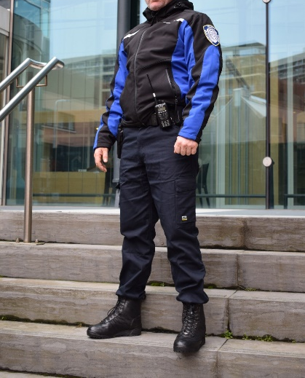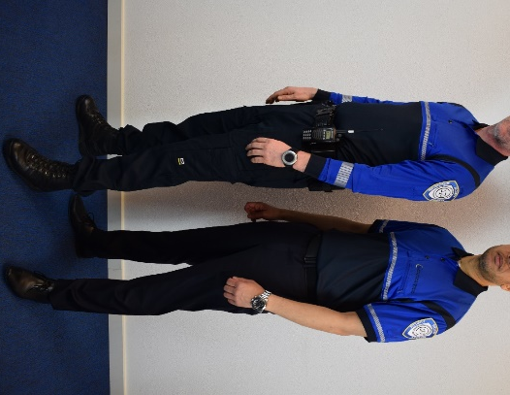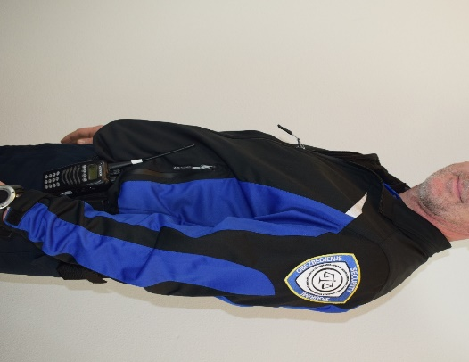  *Considering the nature of the items (uniform) and that the organisation shall continue to maintain the same corporate image, the vendors should be able to supply identical or equivalent (same technical specifications) uniform items. To that end, vendors should be able to present samples of each uniform item for inspection/comparison to the uniform items already in use by KSC.

1.  Item number | 2.  Specifications required | 3.  Specifications offered  (to be completed by the tenderer) | 4.  Notes, remarks,  ref to documentation  (to be completed by the tenderer when necessary) | 5.  Evaluation committee’s notes
1.1 | 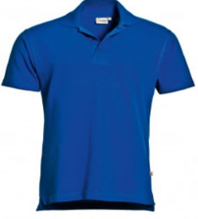  Training polo shirt – Short sleeved  Training polo shirt with specifications as follows:  - Brand: Tricorp; Model: 201003 men; 201010 women (The vendor must be able to supply this exact item, as this is already part of the existing KSC Security uniform already in use);  - Colour: Royal blue pique (cobalt blue). Same colour as the training fleece (see item #1.3);  - 3 button neck opening;  - Buttons in the same colour as the garment;  - Ribbed collar and ribbed sleeve edge;  - 50% Cotton/50% Polyester;  - Fade resistant;  - Size range XS to XXXL or equivalent;  - Men and female variants;  - Split sides;  - No pockets;  - No vendor logos to be visible;  - Basic fit;  - 40 degrees washable;  - Embroidered KSC badge to be sewn on to the upper left arm;  - Off-the-shelf item.
1.2 | Training trouser/Duty Trouser  Tactical trouser with specifications as follows:  - Brand: First Tactical; Model: V2 114011 (The vendor must be able to supply this exact item, as this is already part of the existing KSC Security uniform already in use);  - General description: This item will be used for training and duty;  - Colour: Midnight Navy;  - Fabric: 65% polyester/35% cotton;  - Ripstop;  - Teflon shield finish and strain repellent finish;  - 2-way mechanical stretch;  - Stretch or flexible waist fitting;  - Triple needle stitching;  - Pockets :2 x deep slanting front pockets; 2 x rear pockets with closing flap; 2 x thigh double pockets with closing mechanisms (low profile); 2 x front pen/other equipment pocket; reinforced pocket flaps;  - Double belt loops to accommodate a 5cm duty belt and a trouser belt;  - No visible vendor logos;  - Knee-pad ready;  - Male and female fit across sizes S to XXL or equivalent – W28-46, L30-36;  - Colour protect technology – fade resistant: the fabric holds its colour after 50 washes;  - Off the shelf product
1.3 | 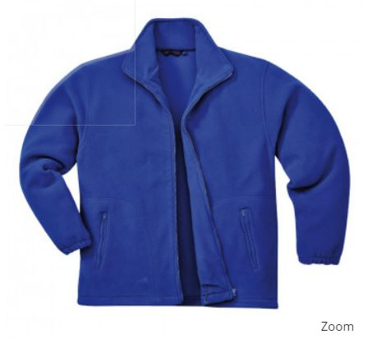  Training fleece  Training fleece with specifications as follows:  - Brand: Tricorp; Model: 301002 (The vendor must be able to supply this exact item, as this is already part of the existing KSC Security uniform already in use);Unisex fleece jacket unlined;  - Colour: Cobalt blue in tone and a close match for the colour of the training polo shirt (item # 1.1);  - Front full-length zipper in a matching colour;  - Standing collar;  - Elasticated cuffed sleeves;  - Weight: 320g (+/- 20g) fleece;  - Two slanting front pockets, zipped;  - No visible vendor logos;  - Embroidered KSC badge to be sewn on to the upper left arm;  - Off the shelf product
1.4 | Duty polo – Short sleeved  Duty polo short-sleeved with specifications as follows:  - Brand: Elbeco; Model: K5213 UFX (The vendor must be able to supply this exact item, as this is already part of the existing KSC Security uniform already in use);  - Light weight Polo shirt with two main colour blocks - dark midnight blue and cobalt blue;  - The lower body and collar in dark midnight blue (see photo). The chest and arms in cobalt blue;  - A broken (not solid) white strip at the join of the two-colour blocks on the chest area and sleeves;  - Three buttons on the neck opening (button colour should match the fabric colour;  - Two invisible microphone holders on the shoulders;  - Ribbed collar for stiffness and presentability. The collar should be edged with a double line and the tips should point left/right as opposed to downwards;  - Ribbed sleeve edges (as opposed to a simple sewed edge);  - Pockets: Dual pen pocket on the left sleeve;  - Sizes: XS to XXXL;  - Fabric: 100% polyester; antimicrobial and machine washable;  - 2 x embroidered KSC arm badges to be stitched on to both upper arms. N.B: The DMU and SSU will require different badges stitched onto the garments;  - Off the shelf product.
1.5 | Duty polo – Long sleeved  Duty polo long-sleeved with specifications as follows:  - Brand: Elbeco; Model: K5223 UFX (The vendor must be able to supply this exact item, as this is already part of the existing KSC Security uniform already in use);  - With the exception of long sleeves, this item has the exact same specifications as item # 1.4 (Duty Polo – Short-sleeved). The short and long-sleeved polo MUST be identical in design, material and colour;
1.6 | Duty gloves  Duty gloves with specifications as follows:  - Colour – Black  - Fabric - practical polyester spandex gloves with microfiber palm and elasticated wrist;  - Sizes: M to XL;  General description: Patrol Gloves - Viper brand or equivalent lightweight patrol glove acceptable
1.7 | Duty soft- shell jacket  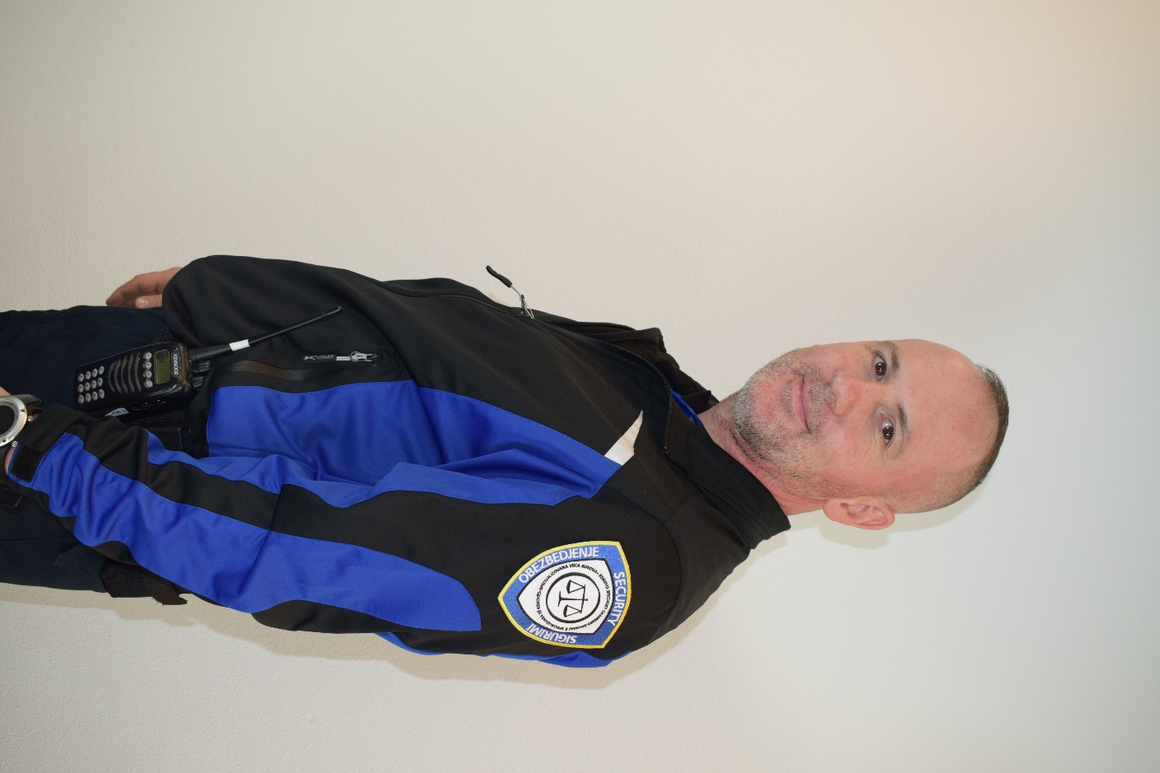  Duty soft-shell jacket with specifications as follows:  - Brand: Kubler; Model: 1141 5227 9946 (The vendor must be able to supply this exact item, as this is already part of the existing KSC Security uniform already in use);  - Colour: black/cobalt blue, as per the duty polo shirt (item # 1.4);  - Fabric: 100% polyester with stretch;  - The garment may have white reflective strips (see photo). These should not be solid or be a dominant feature of the upper body garment. A strip of 2cm maximum is acceptable.  - 2 x front zipped hand pockets - fleece lined;  - 2 inner pockets - one of which is vertical zipped;  - Black zip with draught protection flap (inner or outer);  - Stand up collar (Zip includes collar area);  - Wind protection closure on sleeves and wind protection elastic drawstring on waist;  - Design/length: allows access to a firearm on the gun belt;  - Sizes XS to XXXL;  - Fit: Longer back than front; cut to fit (tapered fit);  - "SECURITY" in white iron-on letters on the rear of garment for SECURITY staff;  - 2 x KSC embroidered badges on upper arms; N.B: The DMU and SSU will require different badges stitched onto the garments;  - No vendor labels/logos to be visible;  - Off-the-shelf product.
1.8 | Duty all-weather jacket  Duty all-weather jacket with specifications as follows:  - Brand: Kubler; Model: 1041 7322 9946 (The vendor must be able to supply this exact item, as this is already part of the existing KSC Security uniform already in use);  - Colour: black/cobalt blue. This garment should be from the same range as the Duty soft- shell garment and have the same colours and location of colour blocks;  - Fabric: 100% polyester with stretch;  - The garment may have white reflective strips (see photo). These should not be solid or be a dominant feature of the upper body garment. A strip of 2cm maximum is acceptable;  - Fabric quality: washable, wind and water resistant, inner padding for warmth;  - Closing: zip with cover flap; zip must be in the colour of the garment;  - Pockets: Minimum of 2 x front zipped hand pockets and x 1 vertical inner zipped pocket;  - Drawstring waist adjustment;  - Elasticated inner sleeve opening;  - Fleece or other warm fabric at neckline;  - Removable hood (zipped attachment) or invisible hood;  - Design: suitable for accessing a firearm on a gun belt;  - Size range: XS to XXXL;  - "SECURITY" in white iron-on letters on the rear of garment;  - 2 x KSC embroidered badges on upper arms; N.B: The DMU and SSU will require different badges stitched onto the garments;  - Vendor labels and logos should be removed or not visible;  - Off-the-shelf product.
1.9 | Duty T-shirt – round neck  - White round neck T-shirt in a cotton (minimum 95%) /coolmax/elastane mix fabric;  - Size range: XS to XXXL;  - Men and ladies fit variants;
1.10 | Embroidered arm badges  Manufacture and application (sewn on) of embroidered arm badges (The vendor must be able to supply this exact item, as this is already part of the existing KSC Security uniform. Therefore, the item needs to be identical to the uniform item already in use). A sample is available and the chosen vendor will be required to make and apply the badges to the upper body uniform items;  - Dimensions: 9x7cm (sample can be provided);  - Shape: a law enforcement style arm shield;  - Thread type: washable, fade resistant, shrink resistant, capable of being ironed;  - Sewn on to both sleeves of upper body garments.
1.11 | Duty belt  - Duty belt for carriage of weapons and other equipment;  - Style: designed as a double belt which fits against the regular trouser belt with Velcro;  - Colour: black;  - Fabric: cordura/ stiffened nylon with an inner of Velcro;  - Size: 5cm deep (± 0.5 cm) with a range of waist sizes to accommodate standard female and male waist lines;  - Clip: black hardened plastic clip fastening.  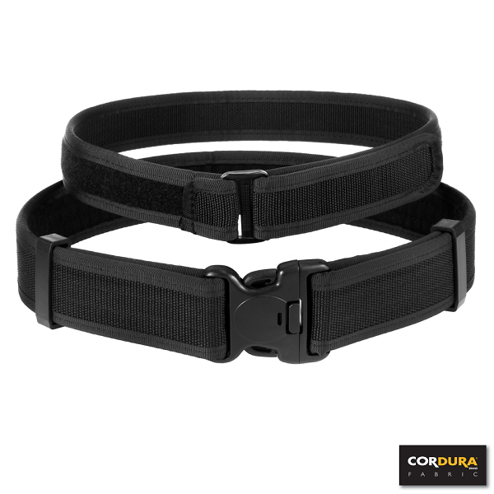
1.12 | Small pouch for latex gloves and handcuff key holder  - Both items must be black and cordura/nylon or webbing type fabric to match the belt (item # 3.1);  - Small pouch for latex gloves: Popper button flap closure;  - Handcuff key holder: flap closure.
1.13 | Torch and belt holder  - Torch: black colour; white light; max output 320 lumens; length between 13.0 and 13.3 cm; 2x AA battery size;  - Torch holder: popper button flap; sized to match the torch specified above;  - Fabric of torch holder: to match that in the belt (item # 1.11).
1.14 | Handcuffs and supplier's handcuff holders  - Handcuffs: LIPS model LH001or equivalent;  - Handcuff holder: open type holder to fit the above handcuffs (suppliers’ holder).

Important information regarding this tender procedure:
- The products offered shall be new and unused.
- The prices quoted must be free of VAT and other taxes.
Delivery timeline: No later than 45 calendar days from receipt by the Contractor of an Order Form issued by the Contracting Authority.
Place of delivery (DDP): Products listed in the above table must be delivered at one of the following location as determined by the Contracting Authority in its sole discretion: Kosovo Specialist Chambers – Raamweg 47 – 2596 HN The Hague (NL).
Warranty coverage for all products listed in the above table: Standard manufacturer's warranty (commencing from the date of their provisional acceptance by the KSC).
The Contractor undertakes to provide the following services at no cost to the KSC:
- Holding by KSC of uniform items in different sizes to facilitate fitting-out of officers as quickly as possible after their arrival at KSC.
- Delivery of named uniform packages to individual officers at the KSC premises.
- Tailoring of all items at the time of issue. *The Contractor has to come to KSC for measuring/tailoring/repairs/collection.
- Holding of sufficient stock at their premises to allow fitting of a newly arrived officers in a Duty Uniform within 3 working days of the individuals arriving at KSC for measuring.

DDP (Delivered Duty Paid) – Incoterms 2020 International Chamber of Commerce – http://www.iccwbo.org/incoterms/

